**AR Map 2Go!**

**Test Plan**

By

**Mr. Parun Pichaiwong 522115043**

Department of Software Engineering

College of Arts, Media and Technology

Chiang Mai University

Project advisor

_________________________________

**Mr. Jayakrit Hirisajja**

**Document History**

|  |  |  |  |  |  |  |
| --- | --- | --- | --- | --- | --- | --- |
| **Document Name** | **Version** | **Status** | **Date** | **Viewable** | **Reviewer** | **Responsible** |
| **Documents** | | | | | | |
| **AR Map 2GO!_Test_Plan_1.0** | AR Map 2GO!_Test_Plan   * Add New System Test * Add New Unit Testing | Reviewed | 07-08-2016 | PP, JH | PP | PP |
| **AR Map 2GO!_Test_Plan_1.1** | AR Map 2GO!_Test_Plan   * Update Document | Reviewed | 05-09-2016 | PP, JH | PP | PP |

**\*PP = Parun Pichaiwong**

**\*JH = Jayakrit Hirisajja**

**Table of Contents**

**1.1 Purpose** 4

**1.2 Software Scope** 4

**1.3 Objective** 4

**1.4 Dependency Document** 4

**2.1 Acronym** 5

**2.2 Definition Acceptance** 5

**2.3 Defect** 5

**2.4 Error** 5

**2.5 Failure** 5

**2.6 Module** 5

**2.7 Integration Test** 6

**2.8 System Test** 6

**2.9 Unit Test** 6

**3.0 System Test Plan** 7

**Appendix** 18

Chapter One | Introduction

A Software Test Plan is a document describing the testing scope and activities. It is the basis for formally testing any software/product in a project.

**1.1 Purpose**

Test Plan document is established to test and find the software error that it occurs during development process to guarantee the quality of the software before delivery. In addition, the test plan is a handbook for test performance it helps to test each function, each unit of the system with the appropriate methodology to get the most quality. According to, after it got the most quality the system will be the most efficiency and acceptance from the customer.

**1.2 Software Scope**

The test plan document describes the testing activity of each function for the “AR Map 2 Go!” to find the error or failure of the system. Also the test plan is made to measure the user requirements and system requirement that it consistency and reliability. Moreover, test plan explains the test types and test methodology of the system as well.

**1.3 Objective**

The objectives of this document to ensure the software quality that the system delivered.

* All functions are consistency and reliability.
* Defining bug-tracking procedure.
* Identify testing task.
* Testing does not effect to another system and not exit the technology environment.

**1.4 Dependency Document**

This software Test Plan is depended on the following documents

* Software Requirement Specification version1.2
* Software Design document version1.2

Chapter Two | Acronym & Definition

**2.1 Acronym**

|  |  |
| --- | --- |
| DFD | Data Flow Diagram |
| IEEE | Institute of Electrical and Electronics Engineers |
| CS | Counter Service |
| SEI | Software Engineering Institute |
| EPG | Engineering Process Group |
| SMM | Software Measurement and Metrics |
| SQA | Software Quality Assurance |

**2.2 Definition Acceptance**

Agreements: Granting of an unqualified consent (whether express or implied) to the terms of a contract by the involved parties. When an offer is received, it is either accepted or countered (with a counter offer). A counter offer obligates the other party to accept it or respond with its own counter offer. Accepting an offer (or a counter offer) creates a binding contract. Sometimes, the term 'subject to contract' is used in offers or acceptances to indicate that the parties intend to be bound only under a formal contract when it is prepared and signed (executed).

**2.3 Defect**

The lack of something necessary or desirable for completion or perfection.

**2.4 Error**

A deviation from accuracy or correctness.

**2.5 Failure**

A failure is the act of falling short of the goal or a person who hasn't achieved what they set out to

**2.6 Module**

A separate unit of software or hardware. Typical characteristics of modular components include portability, which allows them to be used in a variety of systems, and interoperability, which allows them to function with the components of other systems.

**2.7 Integration Test**

A logical extension of unit testing. In its simplest form, two units that have already been tested are combined into a component and the interface between them is tested. A component, in this sense, refers to an integrated aggregate of more than one unit. In a realistic scenario, many units are combined into components, which are in turn aggregated into even larger parts of the program. The idea is to test combinations of pieces and eventually expand the process to test your modules with those of other groups. Eventually all the modules making up a process are tested together. Beyond that, if the program is composed of more than one process, they should be tested in pairs rather than all at once.

**2.8 System Test**

The process of performing a variety of tests on a system to explore functionality or to identify problems. System testing is usually required before and after a system is put in place. A series of systematic procedures are referred to while testing is being performed. These procedures tell the tester how the system should perform and where common mistakes may be found. Testers usually try to "break the system" by entering data that may cause the system to malfunction or return incorrect information. For example, a tester may put in a city in a search engine designed to only accept states, to see how the system will respond to the incorrect input.

**2.9 Unit Test**

A test verifying the functionality of a small portion of code. The primary mode of testing code with Test-Driven Development[/link] and Behavior-Driven Development. Every aspect of application code should be tested by at least one unit test.

Chapter Three | System Test Plan

**3.1 TC-S01: The user can register a new account**

|  |  |
| --- | --- |
| Test ID | TC-S01 |
| Test Case | The user can register a new account. |
| Test Description | Test for displaying the message “Registration Successfully”. |
| Actor | User |
| Procedures | 1. Click on “Sign Up” button in the main page. 2. Input username(E-mail address), password and confirm password. 3. Clicks create account button. |
| Prerequisites Data | Users must run the application before. |
| Input | 1. Username(E-mail address) 2. Password. 3. Confirm password. |
| Expected Output | The system displays dialog to show the message “Registration Successfully”. |

**3.2 TC-S02: The user can delete an account**

|  |  |
| --- | --- |
| Test ID | TC-S02 |
| Test Case | The user can delete an account. |
| Test Description | Test for displaying message “Delete Account Successfully”. |
| Actor | User |
| Procedures | 1. Click on the mini gear icon on the right top of edit profile page. 2. Select “Delete Account” button. 3. Clicks “Yes” to confirm. |
| Prerequisites Data | Users must be login before. |
| Input | - |
| Expected Output | The system displays dialog to show the message “Delete Account Successfully”. |

**3.3 TC-S03: The user can login to the system**

|  |  |
| --- | --- |
| Test ID | TC-S03 |
| Test Case | The user can login to the system. |
| Test Description | Test for displaying the home page. |
| Actor | User |
| Procedures | 1. Click on “Sign In” button in the main page. 2. Input username(E-mail type) and password. 3. Clicks “Sign In” button. |
| Prerequisites Data | Users must be login before. |
| Input | 1. Username(E-mail address). 2. Password. |
| Expected Output | The system displays dialog to show the message “Login Successfully” and go to home page. |

**3.4 TC-S04: The user can log out from the system**

|  |  |
| --- | --- |
| Test ID | TC-S04 |
| Test Case | The user can log out from the system. |
| Test Description | Test for displaying the main page. |
| Actor | User |
| Procedures | 1. Click on the mini gear icon on the right top of edit profile page. 2. Select “Logout” button. 3. Clicks “Yes” to confirm. |
| Prerequisites Data | Users must be login before. |
| Input | - |
| Expected Output | The system displays dialog to show the message “Logout Successfully” and go to main page. |

**3.5 TC-S05: The user can recover the password**

|  |  |
| --- | --- |
| Test ID | TC-S05 |
| Test Case | The user can recover the password. |
| Test Description | Test for displaying the recover password page. |
| Actor | User |
| Procedures | 1. Click on “Sign In” button in the main page. 2. Click on “Forgot Password”. 3. Enters username(E-mail address). 4. Clicks “Submit” button. 5. Go to user mail box and open E-mail link which send from the system. 6. Clicks link on E-mail. |
| Prerequisites Data | Users must run the application before. |
| Input | 1. Username(E-mail address). |
| Expected Output | The system will display the recover password page to the user. |

**3.6 TC-S06: The user can view user profile information**

|  |  |
| --- | --- |
| Test ID | TC-S06 |
| Test Case | The user can view user profile information. |
| Test Description | Test for displaying the view profile page. |
| Actor | User |
| Procedures | 1. Click on the mini gear icon on the right top of edit profile page. 2. Select “View Profile” button. |
| Prerequisites Data | Users must be login before. |
| Input | - |
| Expected Output | The system will display the view profile page. |

**3.7 TC-S07: The user can update profile information**

|  |  |
| --- | --- |
| Test ID | TC-S07 |
| Test Case | The user can update profile information. |
| Test Description | Test for updating the user profile. |
| Actor | User |
| Procedures | 1. Click on “Edit Profile” in profile page. 2. Input name, address, Facebook and mobile phone. 3. Clicks “Update Profile” button. |
| Prerequisites Data | Users must be login before. |
| Input | 1. Name. 2. Address. 3. Facebook. 4. Mobile phone. |
| Expected Output | The system displays dialog to show the message “Update Profile Successfully” and return to profile page. |

**3.8 TC-S08: The user can change profile picture**

|  |  |
| --- | --- |
| Test ID | TC-S08 |
| Test Case | The user can change profile picture. |
| Test Description | Test for displaying a new profile picture. |
| Actor | User |
| Procedures | 1. Click on profile picture in the left top of profile page. 2. Select the photo gallery. 3. Select the photo. 4. Clicks photo again to save the change. |
| Prerequisites Data | Users must be login before. |
| Input | - |
| Expected Output | The system displays a new profile picture to user in profile page. |

**3.9 TC-S09: The user can view the specified map list from the server**

|  |  |
| --- | --- |
| Test ID | TC-S09 |
| Test Case | The user can view the specified location map list from the server database via the application. |
| Test Description | Test for displaying the home page with the location map list row and details. |
| Actor | User |
| Procedures | 1. Login into the system. 2. System will navigate to home page. 3. Clicks on tab “Available map”. |
| Prerequisites Data | Users must be login before. |
| Input | 1. - |
| Expected Output | The system displays the list of all available location map list row to the user at the home page. |

**3.10 TC-S10: The user can view the specified location text title list from the server**

|  |  |
| --- | --- |
| Test ID | TC-S10 |
| Test Case | The user can view the specified location text title list from the server database via the application. |
| Test Description | Test for displaying the home page with text title list row and details. |
| Actor | User |
| Procedures | 1. Login into the system. 2. System will navigate to home page. 3. Clicks on tab “Text & Magazine”. |
| Prerequisites Data | Users must be login before. |
| Input | 1. - |
| Expected Output | The system displays the list of all available text title to the user at the home page. |

**3.11 TC-S11: The user can select the specified map to see more detail**

|  |  |
| --- | --- |
| Test ID | TC-S11 |
| Test Case | The user can select one map from the location map list row to see more detail. |
| Test Description | Test for displaying the selected map detail page. |
| Actor | User |
| Procedures | 1. Login into the system. 2. System will navigate to home page. 3. Clicks on tab “Available Map”. 4. Clicks on the target. |
| Prerequisites Data | Users must be login before. |
| Input | - |
| Expected Output | The system displays the map detail page to show more detail about the selected map with contains location name, specified map picture, scanning condition and help. |

**3.12 TC-S12: The user can select the specified text title from the list to see more detail**

|  |  |
| --- | --- |
| Test ID | TC-S12 |
| Test Case | The user can select one of text title from the list row to see more detail. |
| Test Description | Test for displaying the selected text title detail page. |
| Actor | User |
| Procedures | 1. Login into the system. 2. System will navigate to home page. 3. Clicks on tab “Text & Magazine”. 4. Clicks on the target. |
| Prerequisites Data | Users must be login before. |
| Input | - |
| Expected Output | The system displays the map detail page to show more detail about the selected map with contains text of the location name, specified magazine or specified book that use for, scanning condition and help. |

**3.13 TC-S13: The user can view the 3-dimension object via mobile camera view**

|  |  |
| --- | --- |
| Test ID | TC-S13 |
| Test Case | The user can view 3-dimension object via mobile camera view. |
| Test Description | Test for showing the target’s 3-dimension object via camera view. |
| Actor | User |
| Procedures | 1. The user scans the target (map shape picture or text title) via the application. |
| Prerequisites Data | The user must be login before. |
| Input | - |
| Expected Output | If verification success, the system will show interactive 3D object to the user via mobile camera view. |

**3.14 TC-S14: Administrator can login into the web application on the server.**

|  |  |
| --- | --- |
| Test ID | TC-S14 |
| Test Case | Administrator can login into the web application on the server. |
| Test Description | Test for displaying the home page. |
| Actor | Administrator. |
| Procedures | 1. Click on “Sign In” button in the main page. 2. Input username(E-mail type) and password. 3. Clicks “Sign In” button. |
| Prerequisites Data | Administrator must go to the localhost/AR Map 2go/home.html first. |
| Input | 1. Username(E-mail address). 2. Password. |
| Expected Output | The system displays dialog to show the message “Login Successfully” and go to home page. |

**3.15 TC-S15: Administrator can add the new location information into the system.**

|  |  |
| --- | --- |
| Test ID | TC-S15 |
| Test Case | Administrator can add the new quest package into the system. |
| Test Description | Test for displaying message “Insert complete” after adding the new location information on web service. |
| Actor | Administrator |
| Procedures | 1. Go to URL localhost/AR Map 2Go/admin/addNewLocation.php. 2. Input the require information;   l_name  l_image  l_description  l_total_place  l_status  l_map_id   1. Clicks “Submit” button |
| Prerequisites Data | Administrator must be login before. |
| Input | 1. l_server_id 2. l_name 3. l_image 4. l_description 5. l_total_place 6. l_status |
| Expected Output | The system displays message add the new location complete and insert data into locationDatabase. |

**3.16 TC-S16: Administrator can log out from the system**

|  |  |
| --- | --- |
| Test ID | TC-S16 |
| Test Case | Administrator can log out from the system. |
| Test Description | Test for displaying the main page. |
| Actor | Administrator |
| Procedures | 1. Go to Administrator Home page. 2. Select “Logout” button. 3. Clicks “Yes” to confirm. |
| Prerequisites Data | Administrator must be login before. |
| Input | - |
| Expected Output | The system displays dialog to show the message “Logout Successfully” and go to main page. |

Chapter Four |Unit Test

**Server side**

4.1 UTC-01:

Method : private boolean checkEmail(String email) {}

|  |  |
| --- | --- |
| Test ID | UTC-01 |
| Test Case | User input the Username as Email Address format. |
| Test Description | The for check the user input the Email format. |
| Actor | User |
| Procedures | 1. Input Username by using Email address |
| Prerequisites Data | Users must run application before. |
| Input | - |
| Expected Output | The system not displays system message “Please input Email type” |

4.2 UTC-02:

functionData.php : checkLogin();

|  |  |
| --- | --- |
| Test ID | UTC-02 |
| Test Case | The user can check-in via this application. |
| Test Description | Test for displaying the quest location page. |
| Actor | User |
| Procedures | 1. Select one location from the all locations in the map page. 2. Click on the selected location. 3. Clicks “Play” button. 4. Clicks “Check In” button in quest location page. |
| Prerequisites Data | Users must be login before. |
| Input | - |
| Expected Output | The system displays the quest location page and shows check-in status message. |

4.3 UTC-03:

functionData.php : deleteAccount();

|  |  |
| --- | --- |
| Test ID | UTC-03 |
| Test Case | The user can check-in via this application. |
| Test Description | Test for displaying the quest location page. |
| Actor | User |
| Procedures | 1. Select one location from the all locations in the map page. 2. Click on the selected location. 3. Clicks “Play” button. 4. Clicks “Check In” button in quest location page. |
| Prerequisites Data | Users must be login before. |
| Input | - |
| Expected Output | The system displays the quest location page and shows check-in status message. |

Appendix A

Server database:

Table: member 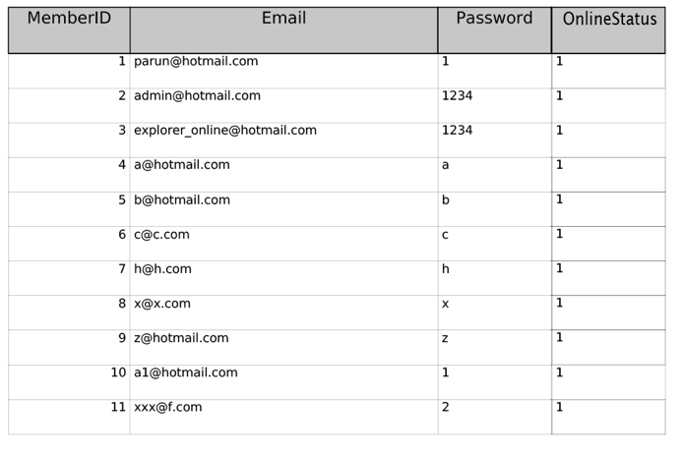

Appendix B

Application database:

Table: user_database



Appendix C

Server database:

Table: locations

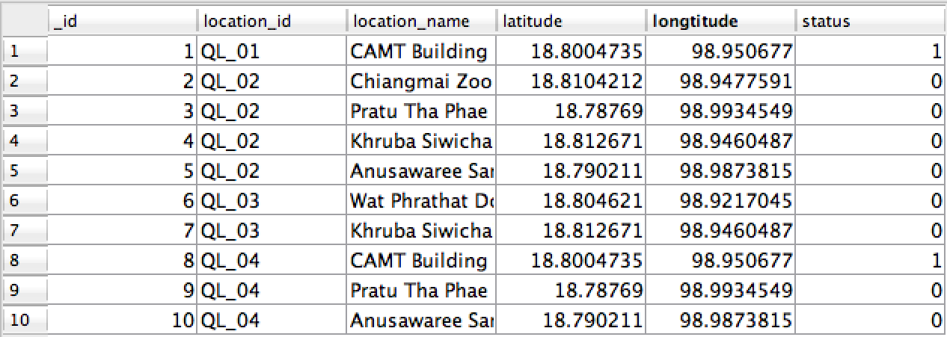

Appendix D

Application database:

Table: regis_locations

| **_id** | **location_r_id** | **location_r_name** |
| --- | --- | --- |
| 1 | QL_01 | CAMT Building |